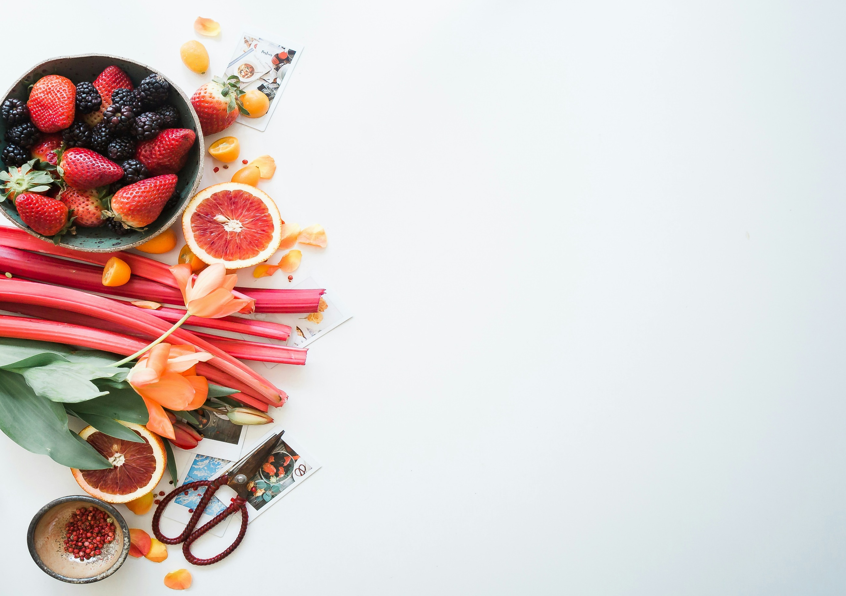

**Nutrition App Using Gemini Pro :**

**Your Comprehensive Guide To Healthy Eating And Well-Being**

**Team ID:** SWTID1720177344

**Team Size:** 4

**Team Leader:** SWAYAM SHETTY

**Team member:** Gunjana Sahoo

**Team member:** Shanmukh Shashankh Vemula

**Team member:** Rishit Katakol

**1. Introduction**

1.1. Project Overview

This project aims to develop an AI Nutritionist Application that leverages Google's Gemini Pro pre-trained model to analyze food images and provide nutritional information. The application offers a user-friendly interface for uploading food images and receiving detailed calorie breakdowns.

1.2. Objectives

- Create an intuitive user interface for image uploads and text inputs

- Integrate Google's Gemini Pro pre-trained model for image analysis

- Implement efficient image processing and model interaction

- Develop a responsive system for displaying nutritional information

- Ensure secure handling of API keys and user data

**2. Project Initialization and Planning Phase**

2.1. Define Problem Statement

In an era of increasing health consciousness, there is a growing need for accessible and accurate nutritional information. This project addresses the challenge of creating a user-friendly tool that can quickly analyze food images and provide detailed calorie information, making nutritional awareness more accessible to the general public.

2.2. Project Proposal (Proposed Solution)

Our solution involves developing a web-based application using Streamlit for the frontend and integrating it with Google's Gemini Pro model via API calls. The application will allow users to upload food images, which will be processed through the Gemini Pro model to generate detailed nutritional information, including calorie counts for each food item.

2.3. Initial Project Planning

- Week 1: Requirements gathering and environment setup

- Week 2: UI development and API integration

- Week 3: Model integration and image processing implementation

- Week 4: Testing, refinement, and documentation

**3. Data Collection and Preprocessing Phase**

3.1. Data Collection Plan and Raw Data Sources Identified

- User-uploaded food images (JPG, JPEG, or PNG formats)

- Optional text inputs for custom prompts

- Google API key for model access

3.2. Data Quality Report

- Ensure proper image format validation (JPG, JPEG, PNG)

- Implement image preprocessing for optimal model input

- Securely store and manage the Google API key

3.3. Data Exploration and Preprocessing

- Develop image processing functionality using PIL

- Implement input sanitization for text prompts

- Design prompt engineering for optimal nutritional analysis

**4. Model Development Phase**

4.1. Feature Selection Report

N/A (Using pre-trained Gemini Pro model)

4.2. Model Selection Report

Gemini Pro was selected due to its advanced image processing and natural language capabilities, making it suitable for analyzing food images and generating detailed nutritional information.

4.3. Initial Model Training Code, Model Validation and Evaluation Report

N/A (Using pre-trained model)

**5. Model Optimization and Tuning Phase**

5.1. Hyperparameter Tuning Documentation

N/A (Using pre-trained model with default settings)

5.2. Final Model Selection Justification

Gemini Pro was chosen as the final model due to its ability to process images and generate coherent, context-aware textual outputs, which is crucial for providing accurate nutritional information.

5.3. Output Screenshots

[Include screenshots of the application interface and sample outputs here]

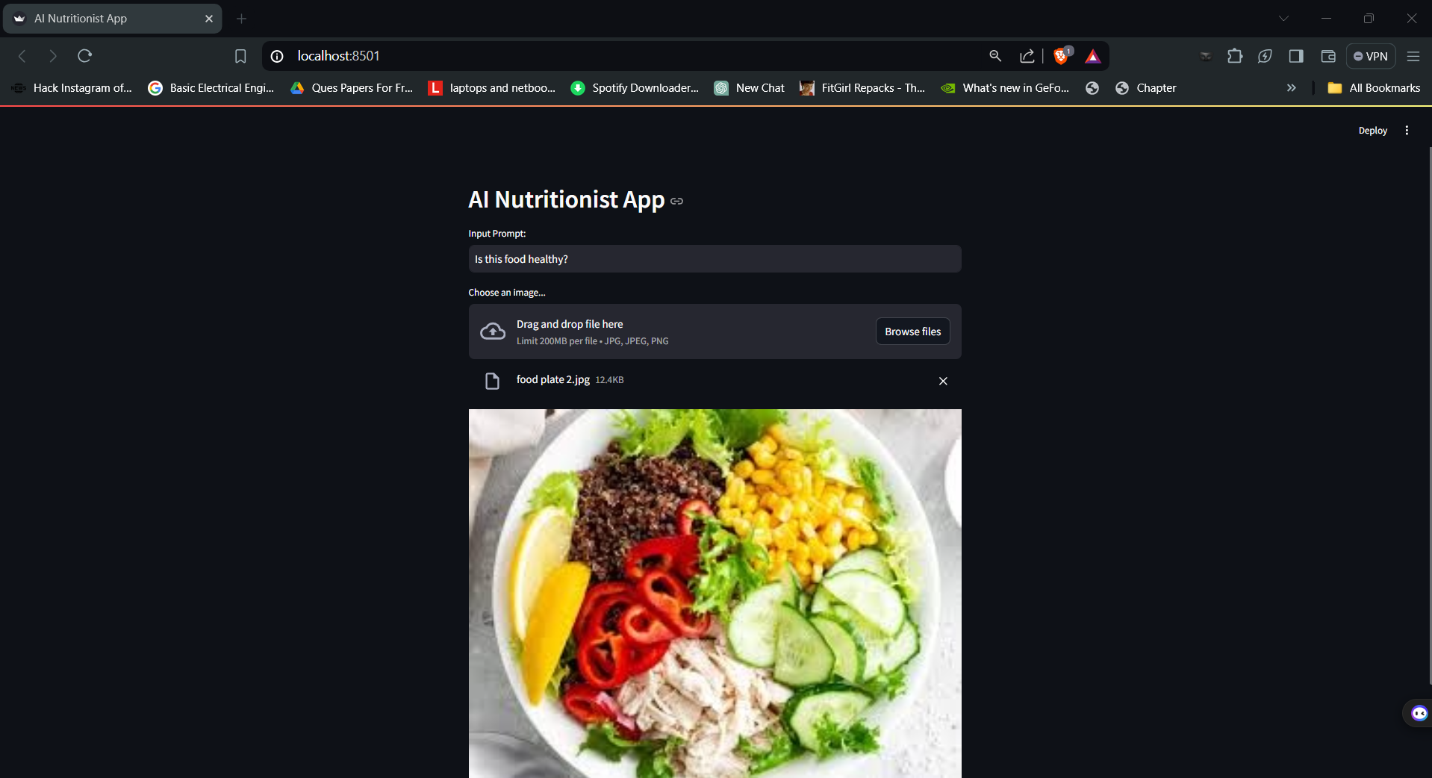

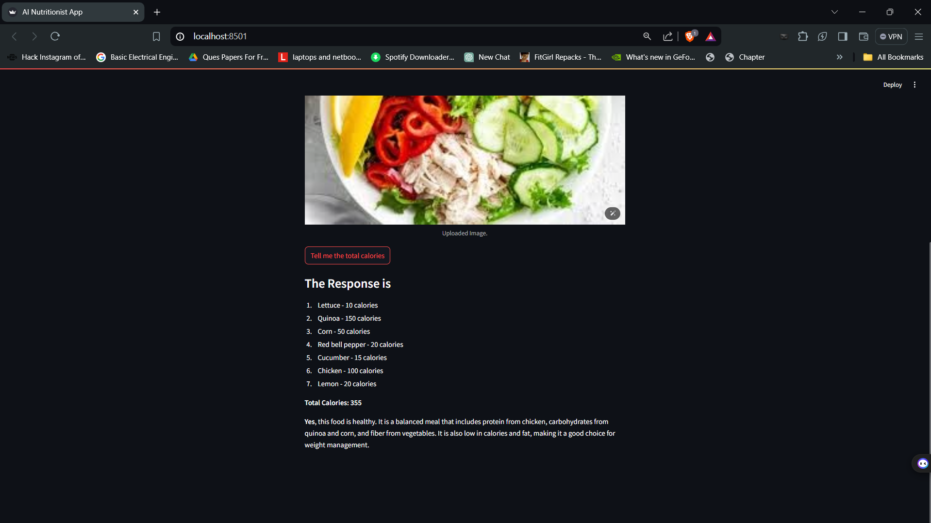

**6. Results**

6.1. Performance Metrics Comparison Report

N/A (Using pre-trained model)

6.2. Advantages & Disadvantages

Advantages:

- User-friendly interface for easy image uploads

- Quick and detailed nutritional analysis

- Flexible input options (image and text)

- Secure API key management

Disadvantages:

- Dependency on internet connection and Google API

- Potential for inaccuracies in image analysis

- Limited to foods visually identifiable by the model

**7. Conclusion**

The AI Nutritionist Application successfully combines advanced AI technology with a user-friendly interface to provide quick and detailed nutritional information from food images. This tool has the potential to significantly improve nutritional awareness and support healthier eating habits.

**8. Future Scope**

- Implement multi-language support

- Add a database of common foods for quicker analysis

- Develop a mobile application version

- Integrate with fitness trackers and health apps

**9. Appendix**

9.1. Source Code

[Include key code snippets or link to full source code repository]

9.2. GitHub & Project Demo Link

[Include links to GitHub repository and live demo if available]

**10. Technical Details**

10.1. Required Libraries

- streamlit

- streamlit_extras

- google-generativeai

- python-dotenv

- PyPDF2

- Pillow

10.2. Installation Instructions

- Open the terminal

- Run: pip install -r requirements.txt

10.3. Google API Key Initialization

- Create a .env file

- Define GOOGLE_API_KEY variable with the generated API key

10.4. Key Functions

- get_gemini_response: Processes input and returns Gemini model response

- input_image_setup: Prepares uploaded images for model input

10.5. Application Hosting

- Launch command: streamlit run app.py

This comprehensive report outlines the development process, technical details, and potential of the AI Nutritionist Application, showcasing its ability to provide valuable nutritional insights through advanced AI technology.